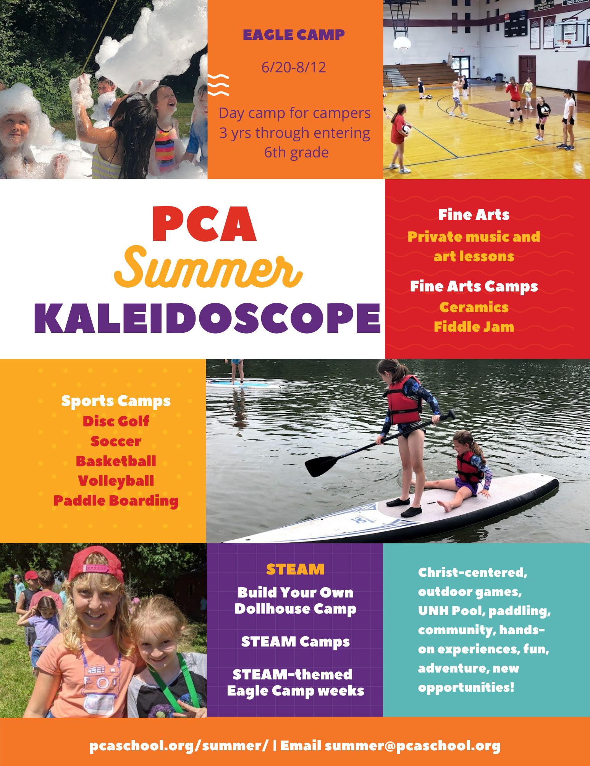

Dear Parents,

PCA is excited to offer summer programming for 2022! Families can choose between a variety of options from week-long camps that include sports, fine arts, and STEAM exploration to Eagle Camp, which is packed with adventures that include getting outdoors, going to the UNH pool, making crafts, and playing games! We are excited to announce our continued partnership with Seven Rivers Paddling! Each Tuesday, Seven Rivers will come to PCA to support our campers with instruction on Stand-Up Paddleboarding and team-building fun -- all from our dock on the Bellamy River!

Eagle Camp is open to children 3 years old through entering Grade 6. Campers are divided into “Eaglets” (3-year-old through entering Kindergarten) and “Eagles” (entering Grade 1 through entering Grade 6).

In addition to Eagle Camp, PCA offers specialized programs for students of all ages through our Kaleidoscope program. Kaleidoscope summer opportunities include basketball and soccer, paddle boarding, ceramics, dollhouse building, Fine Arts private and group lessons, and academic tutoring. Information for those and more can be found below.

To ensure our PCA Community’s camp and enrichment needs are fulfilled, we are opening registration using a tiered approach:

Preferred Registration: currently enrolled PCA students: March 4-March 24
Priority Registration: current families, incoming fall-enrolled students, and referrals of current PCA families: March 25-April 10
Open Camp Registration: all families, including non-PCA families: April 11

Summer Program (Kaleidoscope and Eagle Camp) Registration Deadlines:

Registration Deadline for Music and Art Lessons: June 10th
Registration Deadline for June camps: June 10th
Registration Deadline for July camps: June 24th
Registration Deadline for August camps: July 22nd

Please contact us anytime with questions at Summer@pcaschool.org. We look forward to sharing lots of summer fun with your child!

Sincerely,
The Summer Camp Team

KALEIDOSCOPE CAMPS
*Eagle Camp information begins on page 9*

Week 1-Week 8: 8 Thursdays between 6/20-8/12
Paddle Boarding (Grades: Entering 3-8)
In this one full day a week, participants will be introduced to the basics of paddle boarding. This program includes paddling techniques, self-rescue skills, general water safety, chart reading, principals of Leave No Trace, and team building activities that strengthen confidence, empathy and communication.

Instructor: Seven Rivers Paddling
Day & Time: Thursdays, 9am-3:30pm
Dates: 6/23, 6/30, 7/7, 7/14, 7/21, 7/28, 8/4, 8/11
Registration Fee: $675
Notes: *Minimum 6, maximum 12 students
*Students will be dropped off and picked up from the Lower School loop.
Week 1: 6/20-6/24
Dollhouse Camp (Grades: Entering 1-5)
Let your imagination and creative spirit thrive in PCA's Dollhouse Camp! Over 5 days, each participant will take a plain, wooden IKEA dollhouse and transform it into a unique, custom-designed world for play. Together we will assemble the dollhouse, paint and decorate, create an interior blueprint, and build furniture, people and accessories -- all from our imaginations! Take the dollhouse home at the end of the week and spend the entire summer playing and adding more unique elements. Please bring snacks and water bottle.

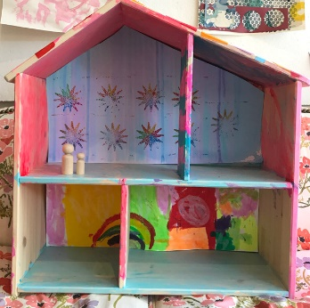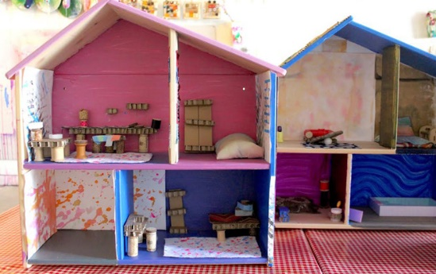

Instructor: Dr. Abood, Lower School Principal
Day & Time: Monday through Friday 9am-12pm
Registration Fee: $175
Notes: *Minimum 3, maximum 8 students
*Students will be dropped off and picked up from the Lower School loop.

Week 1: 6/20-6/24
Ceramics Camp (Grades: Entering 6-9)
Campers will be learning about clay and basic hand building methods. We will focus on pinch, coil, and slab techniques as we make clay creation! Students will be challenged to create a clay whistle and much more! Students with previous clay experience will be reinforcing their understandings of the above techniques. This weeklong class is designed for all levels of clay experience! Please bring snacks and water bottle.

Instructor: Moriah Mazzochi, PCA JH and Upper School Art Teacher
Day & Time: Monday through Friday 9am-12pm
Registration Fee: $225
Notes: *Minimum 6, maximum 15 students
*Students will be dropped off and picked up from the Lower School loop.

Week 2: 6/27-7/1
Ceramics Camp (Grades: Entering 3-5)
Campers will be learning about clay and basic hand building methods. We will focus on pinch, coil, and slab techniques as we make clay creations! Students with previous clay experience will be reinforcing their understandings of the above techniques. This weeklong class is designed for all levels of clay experience! Please bring snacks and water bottle.

Instructor: Moriah Mazzochi, PCA JH and Upper School Art Teacher
Day & Time: Monday through Friday 9am-12pm
Registration Fee: $225
Notes: *Minimum 6, maximum 15 students
*Students will be dropped off and picked up from the Lower School loop.

Week 4: 7/11-7/15
Soccer Shots (Grades: 4 yrs old- entering 3)
Soccer Shots coaches utilize creative and imaginative games to focus on basic soccer skills like dribbling, passing and shooting. They also highlight a positive character trait each session such as respect and teamwork. What to bring: sneakers, water bottle, snacks. Students will be divided into age-appropriate teams.

Instructor: Soccer Shots
Day & Time: Monday through Friday 9am-12pm
Registration Fee: $225
Notes: *Minimum 6, maximum 18 students
*Students will be dropped off and picked up from the Gym Annex doors.

Weeks 4 and 5: 7/11-7/15 and 7/18-7/22
Disc Golf for PE Credit (Grades: Entering 8-12)
Campers will learn fundamental disc golf skills, such as driving, shot-shaping, approach shots and putting, general rules, course etiquette, and different play formats throughout the PCA campus. Campers will also get the chance to apply what they are learning during a camp trip to Bellamy Park Disc Golf Course in Dover, NH. What to bring: sneakers, water bottle, snacks, clothing suitable for outdoor play or a walk in the woods. Come join us in learning one of the fastest growing sports in America! This camp meets the Upper School yearly athletic requirement, providing campers attend all sessions these two weeks.

Instructor: Joel Dewhurst, Semi-Professional Disc Golfer; Carroll Stevens, Fine Arts Director
Day & Time: 2 weeks, Monday through Friday 9am-12pm
Registration Fee: $175
Notes: *Minimum 6, maximum 14 students
*Students will be meet at the garage near the soccer field.

Week 4: 7/11-7/15
Old-Time Fiddle Jam (Grades: Entering 3-8)
Musicians will have fun learning to play some old-time American fiddle tunes. This is open to all violin, viola, cello, and bass players with at least 1 year of experience. Students will display what they have learned during a performance on Friday, 7/15 at 11am. Books can be purchased for $8 on the first day of class, if needed. Musicians will be using Basic Fiddler's Philharmonic Old Time Fiddle Tunes.

Instructor: Susie Stevens, PCA Orchestra and Art Teacher
Day & Time: Monday through Friday 10-11am
Registration Fee: $125
Notes: *Minimum 4, maximum 6 students
*Students will be dropped off and picked up from the Lower School loop.

Week 5: 7/18-7/22
Celtic Fiddle Jam (Grades: Entering 3-8)
Musicians will have fun learning to play some Irish and Scottish fiddle tunes. This is open to all violin, viola, cello, and bass players with at least 1 year of experience. Students will display what they have learned during a performance on Friday, 7/22 at 11am. Price includes fiddle music book needed for the class. Books can be purchased for $8 on the first day of class, if needed. Musicians will be using Basic Fiddler's Philharmonic Celtic Fiddle Tunes.
Instructor: Susie Stevens, PCA Orchestra and Art Teacher
Day & Time: Monday through Friday 10-11am
Registration Fee: $125
Notes: *Minimum 4, maximum 6 students
*Students will be dropped off and picked up from the Lower School loop.

Week 6: 7/25-7/29
Volleyball Camp (Grades: Entering 3-8)
Campers will learn fundamental volleyball skills, such as passing and serving, general rules, court positions, and rotations. Advanced drills will be offered for participants with experienced skillsets. What to bring: sneakers, water bottle, snacks, knee pads (optional).

Instructor: Kevin Carreiro, PCA Volleyball Coach
Day & Time: Monday through Friday 1-4pm
Registration Fee: $150
Notes: *Minimum 6, maximum 15 students
*Students will be dropped off and picked up from the Gym Annex doors.

Week 7: 8/1-8/4 (4-day camp)
Basketball Camp (Grades: Entering 5-8)
Coach Summers will teach drills and challenging games that stress the fundamentals of basketball, including dribbling, passing, shooting, and defense. Teams will be formed and scrimmages will take place each day. What to bring: sneakers, water bottle, snacks.
Instructor: Derek Summers, PCA Athletic Director and Coach
Day & Time: Monday through Thursday 11am-3pm
Registration Fee: $150
Notes: *Minimum 6, maximum 15 students
*Students will be dropped off and picked up from the Gym Annex doors.

Week 8: 8/8-8/12
Basketball Camp (Grades: Entering 1-4)
Campers will play fun games to further develop their dribbling, shooting, passing, and defensive skills while refining their sportsmanship skills and having fun! What to bring: sneakers and water bottle.
Instructor: BJ Mumford, Play-Practice
Day & Time: Monday through Friday10am-12pm
Registration Fee: $195
Notes: *Minimum 6, maximum 12 students
*Students will be dropped off and picked up from the Gym Annex doors.

Week 8: Wednesday, 8/10 (1 day)
STEAM Explorers: Tinker and Build! (Grades: Entering 1-3)
Experience the world of STEAM (science, technology, engineering, art, and math) in this program centered on adventure and innovation. Future engineers will be guided through a day full of designing, tinkering, building, and creating. Rockets, LEGO bricks, and engineering challenges are the center of this jam-packed day and is perfect for children who want to create, question, experiment, and explore.

Instructor: Wayne Moulton, Sages Entertainment
Day & Time: Monday through Friday 9am-3pm
Registration Fee: $325
Notes: *Minimum 5, maximum 8 students
*Students will be dropped off and picked up from the Lower School loop.

Week 8: Thursday, 8/11 (1 day)
STEAM Explorers: Experiment and Code! (Grades: Entering 1-3)
Let’s get a little messy as we take a journey into the world of STEAM (science, technology, engineering, art, and math). Young Scientists will be guided through a day of experiments, questions, and computer programming. Robots, bubbles, and science experiments are the focus of this jam-packed day and is perfect for children who want to create, question, experiment, and explore.

Instructor: Wayne Moulton, Sages Entertainment
Day & Time: Monday through Friday 9am-3pm
Registration Fee: $325
Notes: *Minimum 5, maximum 8 students
*Students will be dropped off and picked up from the Lower School loop.

ON-SITE TUTORING (scheduled as needed)

Does your child need extra support in math, reading, or another subject area? We provide on-site tutoring for any academic subject, subject to teacher availability. Whenever possible, these services can be done with a PCA teacher on campus. Contact Jodi Karnes for more information at jkarnes@pcaschool.org.
Day & Time: Monday-Friday; time and day to be agreed upon prior to beginning tutoring.
Registration Fee:
*$20.00/ 30-minute session
*$30.00/ 45-minute session
*$40.00/ 60-minute session

PRIVATE MUSIC and ART LESSONS

Participate in private lessons and enjoy developing a love for music. Any additional cost of music books or art materials should be paid directly to the instructor. Day & Time: Arranged between parent and instructor. Contact instructor directly if you have questions. *It is the parent’s responsibility to communicate lesson times with summer camp counselors, if applicable.

Registration Fees (unless noted otherwise):
Lesson Type | Fee per Lesson | Weeks in Summer | If 4 Weeks | If 5 Weeks | If 6 Weeks | If 9 Weeks
15-minute lessons | $16.50 | Varies by teacher (see below) | n/a | n/a | n/a | $148.50
30-minute lessons | $33.00 | Varies by teacher (see below) | $132 | $165 | $198 | $297
45-minute lessons | $49.50 | Varies by teacher (see below) | $198 | $247.50 | $297 | $445.50
60-minute lessons | $66.00 | Varies by teacher (see below) | $264 | $330 | $396 | $594

Notes: * Lessons over the summer run between 4 and 9 weeks depending on the availability of each teacher.

*There will be a $25 late fee for all late registrations.

*Makeup Policy: Please notify instructors of any absence 24 hours in advance or as soon as possible if ill. Students are allowed one absence per quarter which may be made up or refunded. Missed lessons without prior notification will be forfeited (and not refunded). Cancellations made by the instructor or by the school will be made up or refunded.
PRIVATE MUSIC TEACHERS

For more information and bios for the below teachers, please visit our Private Fine Arts Lessons webpage.

Private Music and Art Lesson Offerings
Teacher | Instrument(s) | Fees | Email
Moriah Mazzochi | Private Art Lessons | 3 1-hour lessons for $198; materials fees not included and will be based on medium(s) student would like to work with. | mmazzochi@pcaschool.org
Darby Goss | Piano (grades K-12),  Voice (grades 6-12) | 6 weeks  see registration fee above | dgoss@pcaschool.org
Cheryl Rudolph | Woodwinds, Guitar, Ukulele, Percussion | 6 weeks  see registration fee above | crudolph@pcaschool.org
Dan Schmunk | Saxophone, Music Theory, Male Voice (grades 6-12), Trombone and Trumpet (beginner level) | 4 weeks  see registration fee above | dschmunk@pcaschool.org
Jenn Schmunk | Voice (grades 6-12),  Piano | 9 weeks  see registration fee above (for Piano); $40 per 30 min lesson; $60 per 45 min lesson; $80 per 60 min lesson (for Voice) | jenn.schmunk@gmail.com
Susie Stevens | Violin, Viola, Cello | 5 weeks  see registration fee above | sstevens@pcaschool.org
Katrina Veno | Clarinet, Saxophone, Flute, Trumpet, Trombone, Drums | 4 weeks  see registration fee above | kveno@pcaschool.org

Please contact Jodi Karnes, Kaleidoscope Coordinator, at jkarnes@pcaschool.org with any questions regarding the Kaleidoscope summer program.

EAGLE CAMP: FULL-DAY PROGRAM FOR PRESCHOOL-GRADE 6
June 20th – August 12th

EAGLET GROUP (3 years-entering K)
Full Summer Rate $1,820
Full Week Camp (9am-3:30pm) $240
Daily Camp Rate (full day) $50
Drop-off (8:30-9am) included in camp rate
Drop-off (8:30-9am) included in camp rate
Pick-up (3:30-4pm) included in camp rate
*Week 3 Special Pricing: Full week @ $192, with daily camp rate of $50. This is a 4-day week to observe July 4, so there is no camp on Monday, July 4.

EAGLES GROUP (entering 1st-entering 6th)
Full Summer Rate $1,900
Full Week Camp (9am-3:30pm) $250
Daily Camp Rate (M/W/TH/F) $50 (includes trips to the UNH Pool at least M/W/F)
Daily Camp Rate (T) $60 (includes SUP with Seven Rivers Paddling)
Drop-off (8:30-9am) included in camp rate
Pick-up (3:30-4pm) included in camp rate
*Week 3 Special Pricing: Full week @ $202, with daily camp rates of $50 W/TH/F; T $60. This is a 4-day week to observe July 4, so there is no camp on Monday, July 4.

CAMP REMINDERS
Age groups are based on the grade the camper will be entering in the fall.

Eaglet campers must be fully potty-trained AND independent with all bathroom needs (dressing, cleaning self, washing hands, etc.) in order to attend any portion of summer camp.

Lunch and snacks are not provided.

All registration forms must be turned in before participation in any summer program. Forms can be emailed to summer@pcaschool.org or hand-delivered to PCA before the first day of participation. Because camp staff is hired based on registrations, if you register your child for camp and for any reason he/she is not able to come to camp during that time, PCA will still need to be paid in full (if payment has already been processed, NO REFUNDS will take place).

Transfer Credit – Eagle Camp ONLY: If you have already registered your camper for a specific day or week and realize he or she will no longer be able to attend, we will attempt to transfer your credit to another day or week (depending on availability). To do so, please notify summer@pcaschool.org no later than the Friday before your camper’s anticipated absence for the following week. Payment will still be due; no refunds will take place.
Payment for each week’s program must be made on or before the first day of participation.

All payments are non-refundable, unless a program becomes unavailable. If a program becomes unavailable, we will return the full registration fee(s). *There will be a $25 late fee for all late registrations.

EAGLE CAMP THEMES
WEEK 1: June 20-June 24

EAGLETS
3 year old – Kindergarten | Let’s Go to the Zoo! Come join us for an animal adventure through the zoo. We’ll learn about animals, their habitats and have a wild time.

EAGLES
1st – 6th grades | Campus Exploration! Campers will explore the beauty of the 50-acre PCA campus. They will learn about the wildlife around campus and look for evidence of their visits. Campers will walk trails, collect pieces of nature along the way, and make creations with their findings.

WEEK 2: June 27-July 1

EAGLETS
3 year old – Kindergarten | Mad Scientist! This week will be EXPLOSIVE! We will be making Oobleck, slime, and participating in many fun science experiments that will let us explore all things icky, sticky, gooey, slimy, and exploding!
EAGLES
1st – 6th grades | Be an Architect! Campers will build, build, BUILD in this building extravaganza! They will experiment with different building materials, compete in teams to build the highest structures, and learn basic building design to create sturdy structures and strong foundations!

WEEK 3: July 5-July 8 (4-day week)

EAGLETS
3 year old – Kindergarten | Happy Birthday, America! We’ll have a patriotic birthday party for America! Learn history, make our own flags, patriotic windsocks and have some tasty firecracker popcorn!
EAGLES
1st – 6th grades | Freedom Week! Celebrate our independence by learning about what it means to be free! Campers will play patriotic games and create their own fireworks displays.

WEEK 4: July 11-July 15

EAGLETS
3 year old – Kindergarten |Let’s Build with Legos! Join us to become Lego architects! We’ll be using our imaginations to build photo frames, salt dough mini figures, and suncatchers. We’ll also play games using Legos and have enough time to build our wildest creations.

EAGLES
1st – 6th grades | Waterpalooza! This week is all about water! Water games, water slides, water buckets, and water-soaked campers!

WEEK 5: July 18-July 22

EAGLETS
3 year old – Kindergarten |It's a Mystery! Oh no! Our favorite toys are missing! Where could they be? Let’s learn how to be detectives and solve this mystery. Campers will follow clues to solve a new mystery each day.
EAGLES
1st – 6th grades | Sports Week! Familiar sports, new sports. Indoor sports, outdoor sports. Competitive sports, silly sports! Campers will experience all kinds of sports during this fun, action-packed week!

WEEK 6: July 25-July 29

EAGLETS
3 year old – Kindergarten |Ahoy, Matey! Come join us on the high seas for some swashbuckling adventures! Search for treasure, walk the plank and find out what a pirate’s life is all about.
EAGLES
1st – 6th grades | Mad Scientist! Bubbles, volcanoes, and egg drops are all in order for this exciting week! Campers will get to experiment, discover, make messes, and use their critical thinking skills to help solve messy problems!

WEEK 7: August 1-August 5

EAGLETS
3 year old – Kindergarten |Wild, Wild West! This week we’ll take a trip to the wild, wild west! We'll go panning for gold, pick out our own 'horse' and do some trail riding. We'll even rustle up some grub in front of our own cowboy 'campfire'!

EAGLES
1st – 6th grades | Community Service Week! Campers will put words and ideas into motion this week, thinking of ways to help our community, spreading kindness, and serving others! Campers will be challenged to spot needs and find ways to shine the light of Jesus on our families, PCA community, and beyond!

WEEK 8: August 8-August 12

EAGLETS
3 year old – Kindergarten |La Fiesta! We’ll end camp with a fun Mexican fiesta! We’ll create beautiful sand art, make maracas, sombreros, and more. The week will end with mariachi music and pinatas at our very own Mexican fiesta.
EAGLES
1st – 6th grades | Creatively YOU! Explore creativity through various forms of art and practice thinking outside the box to solve all sorts of complex problems. Campers will share how they express themselves, as well as learn new forms of creative exploration!
DAILY ACTIVITY DESCRIPTIONS
Worship and Devotions: Campers will begin their day together with worship, prayer, and devotions.
Outdoor Games and Sports: Campers will be led in a variety of both sports-based, personal skill and team-building games.
Arts and Crafts: Campers will experience a variety of activities intended to spark their creativity.
Quiet Time: Campers will unwind and relax with a great book or a calming game/activity.
Indoor Games: Campers will participate in indoor group games and board games.
Outdoor Adventures: Campers will spend time outside exploring nature, having scavenger hunts, and building camping skills.
STEM: Campers will participate in a variety of hands-on activities that combine Science, Technology, Engineering and Math.
Waterfront: Campers will enjoy stand-up paddleboarding lessons, supported by the professionals from Seven Rivers Paddling.
Water Play: Campers will participate in water games and activities, including slip-n-slide baseball, on a weekly basis.

SAMPLE SCHEDULE: EAGLET GROUP (3-year-olds to entering K)
 | Monday | Tuesday | Wednesday | Thursday | Friday
8:30-9:00 | Drop-Off | Drop-Off | Drop-Off | Drop-Off | Drop-Off
9:00-9:15 | Morning Mania | Morning Mania | Morning Mania | Morning Mania | Morning Mania
9:15-9:30 | Praise Songs & Bible Story | Praise Songs & Bible Story | Praise Songs & Bible Story | Praise Songs & Bible Story | Praise Songs & Bible Story
9:30-10:30 | Arts & Crafts | Arts & Crafts | Arts & Crafts | Arts & Crafts | Arts & Crafts
10:30-10:45 | Snack | Snack | Snack | Snack | Snack
10:45-11:15 | Outdoor Games & Sports | Outdoor Games & Sports | Outdoor Games & Sports | Outdoor Games & Sports | Outdoor Games & Sports
11:15-12:00 | STEM Activities | STEM Activities | STEM Activities | STEM Activities | STEM Activities
12:00-12:45 | Lunch | Lunch | Lunch | Lunch | Lunch
12:45-1:00 | Story Time | Story Time | Story Time | Story Time | Story Time
1:00-2:00 | Nap/Quiet Time | Nap/Quiet Time | Nap/Quiet Time | Nap/Quiet Time | Nap/Quiet Time
2:00-2:30 | Water Play | Water Play | Water Play | Water Play | Water Play
2:30-3:30 | Outdoor Play | Outdoor Play | Outdoor Play | Outdoor Play | Outdoor Play
3:30-4:00 | Pick-Up | Pick-Up | Pick-Up | Pick-Up | Pick-Up
SAMPLE SCHEDULE: EAGLES GROUP (Grade 1- Grade 6)
 | Monday | Tuesday | Wednesday | Thursday | Friday
8:30-9:00 | Drop-Off | Drop-Off | Drop-Off | Drop-Off | Drop-Off
9:00-9:30 | Worship &  Devotions | Worship &  Devotions | Worship &  Devotions | Worship &  Devotions | Worship &  Devotions
9:30-10:00 | Weekly Theme Activities | Weekly Theme Activities | Weekly Theme Activities | Weekly Theme Activities | Weekly Theme Activities
10:00-10:15 | Snack | Snack | Snack | Snack | Snack
10:15-11:00 | Outdoor Adventure/STEAM | Waterfront: Paddle  Boarding/  Arts and Crafts/  Indoor Games | Outdoor Adventures/ STEAM | Outdoor/ Water Play | Outdoor AdventuresSTEAM
11:00-12:15 | Lunch |  | Lunch |  | Lunch
12:15-12:45 | UNH Pool | Lunch | UNH Pool | Lunch | UNH Pool
12:45-2:00 |  | Waterfront: Paddle  Boarding/  Arts and Crafts/  Indoor Games |  | Quiet Time  Arts & Crafts/ Indoor Games
2:00-3:00 |  |  |  | Water Play
3:30-4:00 | Pick-Up | Pick-Up | Pick-Up | Pick-Up | Pick-Up

